Experiment 9: digital voltage meter experiment
To keep up with an experiment is similar, but the data is calculated.
Required components：
Potentiometer *1：
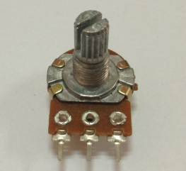
Bread board *1

Bread board jumper *1 tie
In this experiment we will the resistance value of the potentiometer transformation is an analog value is read out, and then show examples of application to the screen, and this is our after the completion of the required experimental functions must master.
We need to in accordance with the following circuit graph to connect the physical map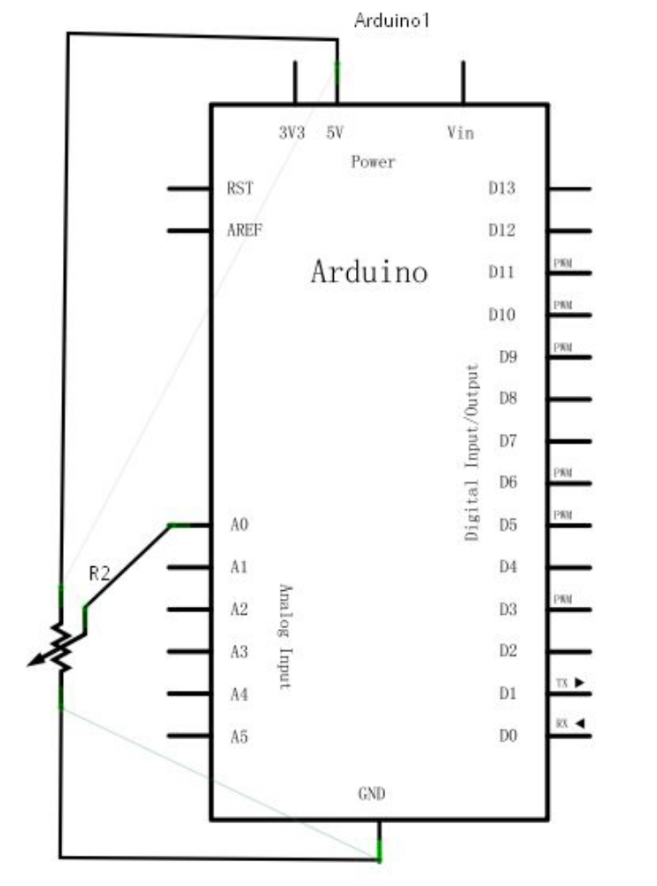
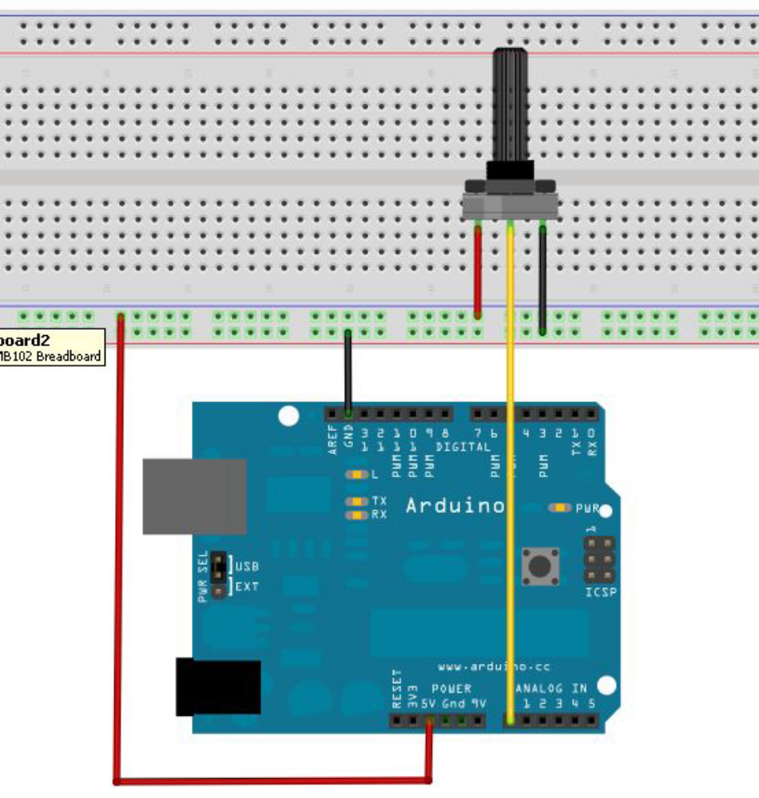
We use a simulation of the 0 interface.
The preparation of the program is also very simple, more about the statement on the frontIntroduced here is no longer to say.
The following is a reference to source program:
int potpin=0; //Define analog interface 0
int ledpin=13; //Define analog interface 13
int val=0; //Will define the variable Val, and assign the initial value of 0
int v;
void setup()
{
pinMode(ledpin,OUTPUT); //Define digital interface as output interface
Serial.begin(9600); //Set the baud rate to 9600
}
void loop()
{
digitalWrite(ledpin,HIGH);//Light digital interface 13 LED
delay(50); //Delay 0.05 seconds
digitalWrite(ledpin,LOW);//Extinguishing digital interface 13 LED
delay(50); //Delay 0.05 seconds

val=analogRead(potpin); //Read the value of the analog interface 0, and assign it to the val
v=map(val,0,1023,0,500);
//function declaration map(x,Amin,Amax,Bmin,Bmax)
Return value type long
The number of 0-1023 interval mapping to the number of 0-500, in fact, can be understood as a proportion of the relationship。

Serial.println((float)v/100.00); //Shows the value of V
}The reference program uses Arduino digital 13 built-in LED lights, each time value will lights flash once.
Program to burn in, open the serial port.。
The following is the analog values read out. And with the voltage meter to measure the voltage of the input port A0. There is a picture of the truth!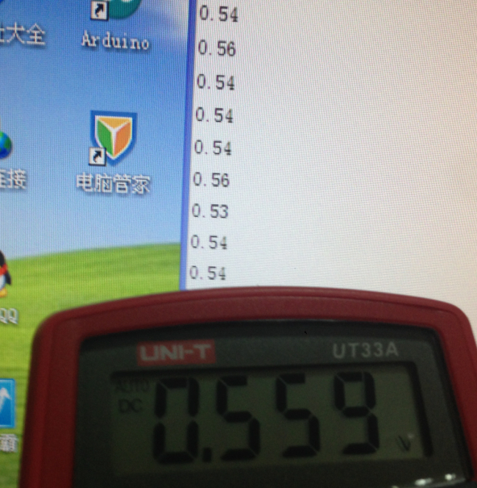
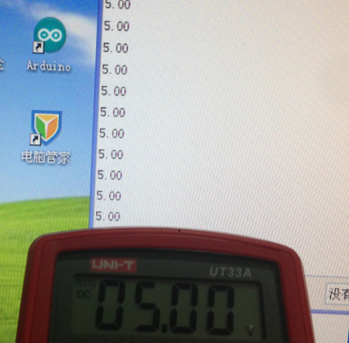

The experiment here is complete, when you rotate the potentiometer knob can see numerical changes on a screen, from the experimental results shows that voltage meter is quite accurate。

